**Constructions**

1. **To divide a line segment internally in a given ratio m: n**, where both m and n are positive integers, we follow the steps given below:

Step 1: Draw a line segment *AB* of given length by using a ruler. Step 2: Draw any ray *AX* making an acute angle with *AB*.

Step 3: Along *AX* mark off (*m + n*) points *A*1, *A*2,………*A*m-1, *Am+1,………,Am+n*, such that *AA1 = A1A2 = Am+n-1 Am+n*.

Step 4: Join BAm+n

Step 5: Through the point *Am,* draw a line parallel to *Am+n*B by making an angle equal to *AAm+nB* at

*Am*, intersecting AB at point P.

The point *P* so obtained is the required point which divides *AB* internally in the ratio *m: n*.

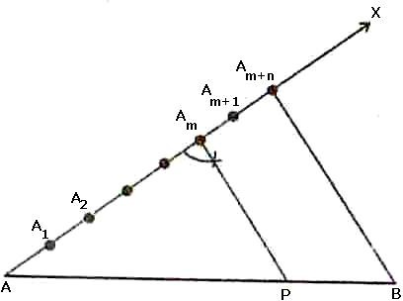

## Justification

In *ABAm**n* , we observe that

*Am P* is parallel to

*Am* *n B* . Therefore, by Basic Proportionality theorem,

we have:

*AAm Am Am**n*

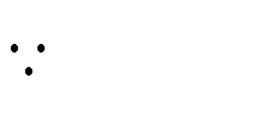

 *AP PB*

⇒ *AP*  *m*

 *AAm*

 *m* , by construction

*PB n*

⇒ *AP* : *PB*  *m* : *n*

 

 *Am Am**n n* 

Hence, *P* divides *AB* in the ratio *m: n.*

### Alternative method to divide a line segment internally in a given ratio m: n

Example

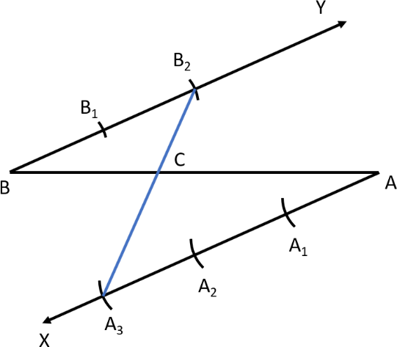Find the point C such that it divides BA in ratio 2:3

Steps of Construction :

* 1. Draw any ray XA making an acute angle with BA.
  2. Draw a ray YB parallel to XA by making ∠YBA equal to ∠XAB.
  3. Locate the points A1, A2, A3 (m = 3) on AX and B1, B2 (n = 2) on BY such that AA1 = A1A2 = A2A3 = BB1 = B1B2.
  4. Join A3B2. Let it intersect AB at a point C Then BC : CA = 2:3

## Justification

Here BB2C  AA3C …AA test

BB2 AA3

 BC ...c.p.s. t . AC

1.  BC
2. AC
3. The ratio of the sides of the triangle to be constructed with the corresponding sides of the given triangle is known as a **scale factor**. The scale factor may be less or greater than 1.
4. If the scale factor is less than 1, then the new figure will be smaller in comparison to the given figure.
5. If the scale factor is greater than 1, then the new figure will be bigger in comparison to the given figure.

# Construction of Triangle Similar to given Triangle

 *m* *th*

Consider a triangle *ABC*. Let us construct a triangle similar to  *ABC* such that each of its sides is   of

*n*

 

the corresponding sides of  *ABC*.

## Steps of constructions when *m < n*:

Step 1: Construct the given triangle *ABC* by using the given data.

Step 2: Take any one of the three side of the given triangle as base. Let *AB* be the base of the given triangle.

Step 3: At one end, say *A*, of base *AB*. Construct an acute angle *BAX* below the base *AB*. Step 4: Along *AX* mark off *n* points *A1, A2, A*3,………, *An* such that

*AA1 = A1A2 = ……… = An-1 An*

Step 5: Join *AnB*

Step 6: Draw *AmB’* parallel to *AnB* which meets *AB* at *B*’. Step 7: From *B*' draw *B*'*C*'||*BC* meeting *AC* at *C*'.

Triangle *AB*'*C*' is the required triangle each of whose sides is

 *m* *th*

 

*n*

 

of the corresponding side of Δ*ABC*.

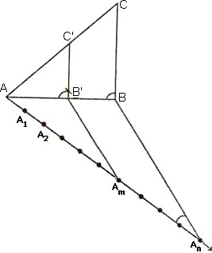X

## Justification

Since *Am B* '|| *An B*. Therefore

*AB* '  *AAm*

*B* ' *B Am An*

[by basic proportionality theorem]

⇒ *AB* '  *m*

*B* ' *B n*  *m*

⇒ *B* ' *B*  *n*  *m*

*AB* ' *m*

Now

*AB AB* '

 *AB* ' *B* ' *B*

*AB* '

⇒ *AB*  1 *B* ' *B*  1 *n*  *m*  *n*

*AB* '

⇒ *AB* '  *m*

*AB n*

*AB* ' *m m*

In triangles *ABC* and *AB*’*C*’, we have

*BAC*  *B* ' *AC* '

and

*ABC*

 *AB* '*C* '

So, by AA similarity criterion, we have

*AB* '*C* '  *ABC*

⇒ *AB* '  *B* '*C* '  *AC* '

*AB BC AC*

⇒ *AB* '  *B* '*C* '  *AC* '  *m AB BC AC n*

## Steps of construction when m > n:

Step 1: Construct the given triangle by using the given data.

Step 2: Take any one of the three sides of the given triangle and consider it as the base. Let *AB* be the base of the given triangle.

Step 3: At one end, say *A,* of base *AB*. Construct an acute angle *BAX* below base AB i.e., on the opposite side of the vertex *C*.

Step 4: Along *AX* mark off *m* (large of m and n) points *A1, A2, A3,………Am* of *AX* such that

*AA1 = A1A2 = ………= Am-1Am.*

Step 5: Join *AnB* to *B* and draw a line through Am parallel to *AnB*, intersecting the extended line segment

*AB* at *B*'.

Step 6: Draw a line through *B*' parallel to *BC* intersecting the extended line segment *AC* at *C*'. Step 7: Δ*AB*'*C*' so obtained is the required triangle.

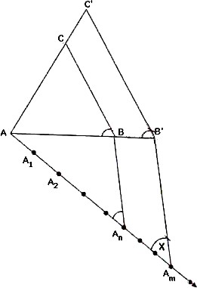

## Justification

Consider triangle *ABC* and *AB’ C’*. We have:

*BAC*  *B* ' *AC* '

*ABC*  *AB* '*C* '

So, by *AA* similarity criterion,

*ABC*  *AB* '*C* '

⇒ *AB AB* '

 *BC* 

*B* '*C* '

*AC AC* '

*In* *A Am B* ', *AnB* || *AmB* '.

 *AB* 

*BB* '

*AAn An Am*

⇒ *BB* '  *An Am AB AAn*

⇒ *BB* '  *m*  *n AB n*

⇒ *AB* ' *AB*  *m*  *n AB n*

⇒ *AB* '  1  *m*  *n AB n*

⇒ *AB* '  *m AB n*

From (i) and (ii), we have

*AB* '  *B* '*C* '  *AC* '  *m AB BC AC n*

The tangent to a circle is a line that intersects the circle at exactly one point. Tangent to a circle is perpendicular to the radius through the point of contact.

# Construction of Triangle to a Circle from a point outside the Circle

### Construction of a tangent to a circle from a point outside the circle, when its centre is known

The steps of constructions are as follows:

Step 1: Join the centre *O* of the circle to the point *P*.

Step 2: Draw perpendicular bisector of *OP* intersecting *OP* at *Q*.

Step 3: With *Q* as centre and radius *OQ*, draw a circle. This circle has *OP* as its diameter. Step 4: Let this circle intersect the first circle at two points *T* and *T*'. Join *PT* and *P T*' *.*

*PT* and *P T*' are the two tangents to the given circle from the point P.

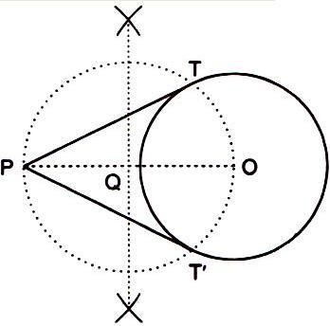

**Justification**

Join *OT* and *O T*'

It can be seen that *PTO* is an angle in the semi-circle. We know that angle in a semi-circle is a right angle.

 *PTO* = 90

⇒ *OT*  *PT*

Since *OT* is the radius of the circle, *PT* has to be a tangent of the circle. Similarly*, PT*' is a tangent of the circle.